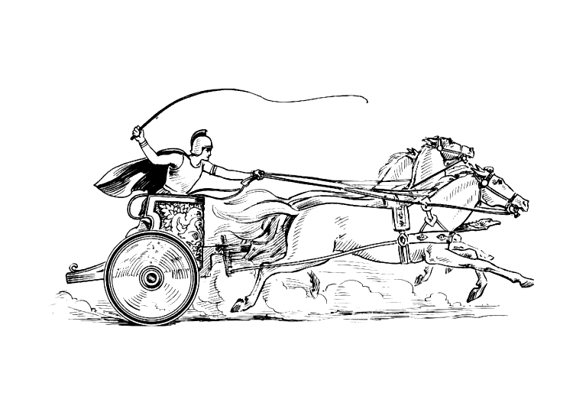Manduessedum - Mancetter Village (Place of War Chariots)
Mancetter Parish Council
Serving the People of Mancetter and Ridge Lane

You are invited to the Parish Council Meeting
to be held in the Schoolroom of St Peter’s Church Mancetter
on Tuesday 28th November 2023 at 7pm.

AGENDA

- Welcome and Apologies.

- Chairman’s request that anyone recording the meeting make themselves known, to allow
openness and recognise practicalities.

- Declared Notice of Interest by Councillors concerning Agenda Items.

- Public Question time of up to 15 Minutes for Members of the Public to raise issues.

- Police, County and Borough Councillor feedback.

- Minutes of the last meeting.

To accept the draft minutes of the Parish Council Meeting held on 26th September 2023.

- Matters Arising from the Parish Council Meeting on 26th September 2023.

- Feedback from Correspondence, Consultations and Meetings.

- MIRA Application feedback submitted regarding Traffic Movements and Environmental Impact within Mancetter Parish of Left In and Out at Woodford Lane. 23rd October 2023.
- Overweight Lorries and damaged and dirty road sign issues reported to Police and County Highways.
- A request for the re-instatement of Quarry Liaison meetings at Mancetter Quarry to discuss the future of the site.
- Meeting with Parishioners concerning Outline Access Application for housing to the rear of the White Hart Car Park in Ridge Lane. 25th October 2023.
- Consultation on Public Spaces Protection Order for Dog Fouling by NWBC. 6th November 2023.
- Initial Consultation from NWBC on 9th November 2023 regarding proposed changes to the Local Plan including:

The Sustainability Scoping Report
The Statement of Community Involvement
The Gypsy and Traveller Development Plan Document
Call for sites.

- Letter to residents of Harpers Lane regarding a proposal to alter the road layout. 14th November 2023.
- WALC AGM and Conference 15th November 2023 Stratford-Upon-Avon.
- Appeal Process meeting on Microsoft Teams for Barn Fishery 16th November 2023 in preparation for the hearing scheduled for 5th December 2023.
- Town and Parish Council Reference Group Meeting. 16th November 2023.
- Levelling up meeting 22nd November 2023 at Mancetter Memorial Hall.

- Planning Matters and New Applications since the previous meeting:

- Planning Matters

- Potential for Listing the White Hart Inn Ridge Lane.
- Clearing of Land to the rear of 90 -92 Mancetter Road.
- Land encroachment to the rear of The Coppice Mancetter.

- Update on Approved and Pending Applications

- Notification of an Appeal Hearing regarding an application for 7 Holiday Lodges at Delamere in Purley Chase Lane. – Refusal Upheld.

- PAP/2023/0229 – Mancetter Wharf – Erection of Office Building including landscaping and parking – Granted.

- PAP/2023/0280 – Sovereign Motor Company – Proposed extension to existing vehicle workshop to be used as an MOT facility. – Pending

- PAP/2023/0283 – Sovereign Motor Company – Change of use for part of site to vehicle sales - Pending

- PAP/2023/0324 – Outline Access application for construction of three dwellings to the rear of the White Hart Inn Ridge Lane. – Pending.

- PAP/2023/0334 – Change of use from Agricultural to Residential The Dutch Hay Barn Whitehall Farm Atherstone Road Hartshill – Pending following Planning and Development Board Meeting.

- To discuss any new applications received.

There are new applications for windows at the grade II listed Railway Cottage in Quarry Lane using reference numbers:

PAP/2023/0460 and PAP/2023/0464.

- Exclusion of the Public and Press

To consider whether, in accordance with Section 100A(4) of the Local Government Act 1972, the public and press be excluded from the meeting for the following items of business, on the grounds that they involve the likely disclosure of exempt information as defined by Schedule 12 A to the Act.

- To review the contracted hours and salary scale of the Parish Clerk and Responsible Financial Officer in preparation for budget setting.

- To note the payroll implications of the November Public Sector Pay Award backdated to April 2023.

- Update on McCloud Pensions Ruling and back pay relating to the retired Clerk/RFO.

- To discuss a confidential report received by the Parish Council in relation to Public Liability Insurance.

- To consider a financial request in relation to eligibility for In Parish Cemetery Fees.

Agenda items 10 a ,b, c, d and e will involve the disclosure of confidential information relating to individuals. Therefore any members of the public will need to excluded whilst this discussion takes place.

- Finance.

- Signing of all payments since the last meeting in accordance with the Bank Mandate.

- To approve a partnership working arrangement with Mancetter Memorial Hall to rent a digital phone line using the Parish Council existing telephone number with 4G back up if WIFI goes down.

- To receive provisional budget figures and current expenditure for this year, in order to discuss requirements for the next financial year and agree a draft budget to form the basis of setting the precept.

- To review the existing reserve provision in preparation for new and ongoing projects, incorporating Election costings.

- To review the Allotment Rents as part of budget planning.

- Cemetery and Maintenance around the Parish

- Update on a proposed programme for tree surveys.
- Approval of a memorial bench in the cemetery.
- Authorisation for artwork on the new parish noticeboards in partnership with The Roman Mancetter Project, and confirmation of final costing.

- Date of next meeting-

TUESDAY 23rd January 2024
7PM AT ST PETERS CHURCH SCHOOLROOM.

Signed 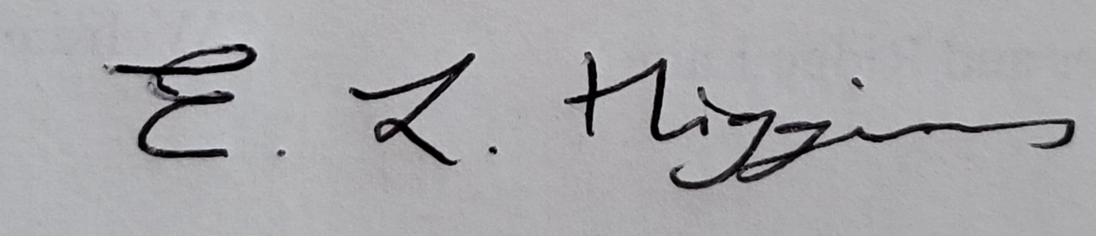

Date 23rd November 2023.

Elane Higgins
Parish Clerk Mancetter Memorial Hall Old Farm Road Mancetter CV9 1QN Tel: 01827 722552 Email: parishclerk@mancetter.org.uk
Website: www.mancetter.org.uk

Manduessedum - Mancetter Village
(Place of War Chariots)
Mancetter Parish Council
Serving the People of Mancetter and Ridge Lane

